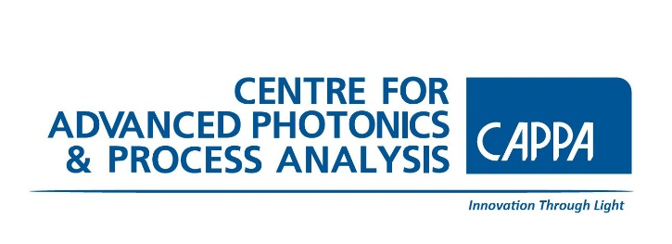 Centre for Advanced Photonics & Process Analysis (CAPPA)
Transition Year Physics & Maths Programme
Application Form 2022 - complete and return by 17 January 2022 to:
danielle.burke@mtu.ie or martina.connolly@tyndall.ie
Please note this programme is in high demand and should this programme fill before 17 January will close earlier.
Important:
- Please attach a copy of your Junior Cert results with the application.
- Please attach a letter of Indemnity from your School.
APPLICATIONS SUBMITTED WITHOUT THESE DOCUMENTS WILL NOT BE CONSIDERED
Student Name
Student Phone Number
Email
Parent/Guardian Name
Parent/Guardian Telephone Number
School
Contact Teacher & email or phone. no.
Junior Certificate Exam Results | Subject Level (O or H) Grade  Other comments:
List, in order of preference, the types of career that interest you | Career choice  1.  2.  3.  4.
Why would you like to participate in the CAPPA TY Physics & Maths Programme?
(100 words max)

