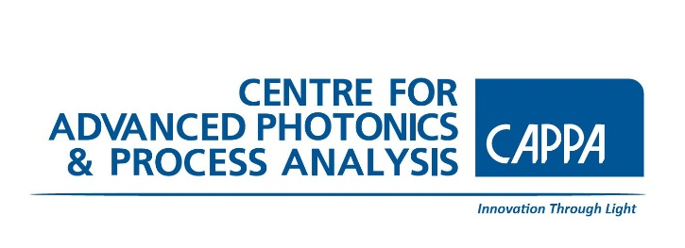 Centre for Advanced Photonics & Process Analysis (CAPPA)
Transition Year Physics & Maths Programme 2023
Application Form 2022 - complete and return by 1st December 2022
to: TYprogramme@cappa.ie
Please note this programme is in high demand and should this programme fill before 1st December will close earlier.
Important:
- Please attach a letter of Indemnity from your School.
- Applications will not be looked at without consent from a guardian.
- Consent forms can be found on https://www.cappa.ie/cappa-ty-programme-2023
APPLICATIONS SUBMITTED WITHOUT THESE DOCUMENTS WILL NOT BE CONSIDERED

Student Name
Student Phone Number
Email
Parent/Guardian Name
Parent/Guardian Telephone Number
School
Contact Teacher & email or phone. no.
Junior Certificate Exam Results | Subject Level (O or H) Grade  Other comments:
Have you taken physics as a TY subject? | Yes  No  Comment
Are you taking physics as a leaving cert subject? | Yes  No  Maybe
List, in order of preference, the types of career that interest you | Career choice  1.  2.  3.  4.
Why would you like to participate in the CAPPA TY Physics & Maths Programme?
(100 words max)

